EXPERIMENT-9

NAME: Yuvaraj A ROLL NO:240701809
Design input forms that validate data (e.g., email, phone number) and display error messages using HTML/CSS, JavaScript
AIM:
The aim is to design input forms that validate data, such as email and phone number, and display error messages using HTML/CSS and JavaScript with Validator.js
Step 1: Setting Up the HTML Form Start by creating an HTML form with input fields for the email and phone number
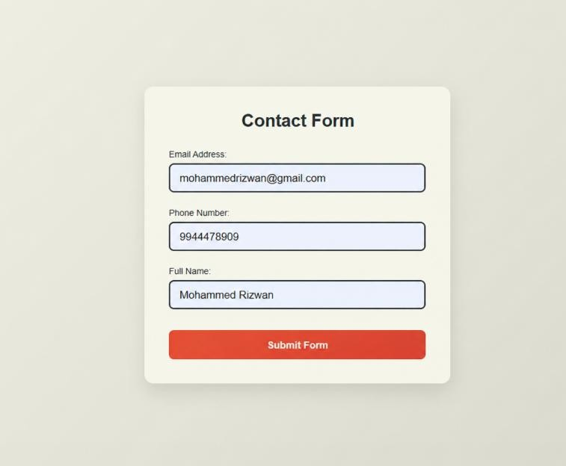
Step 2: Styling the Form with CSS Next, add some basic styling to make the form look nice.
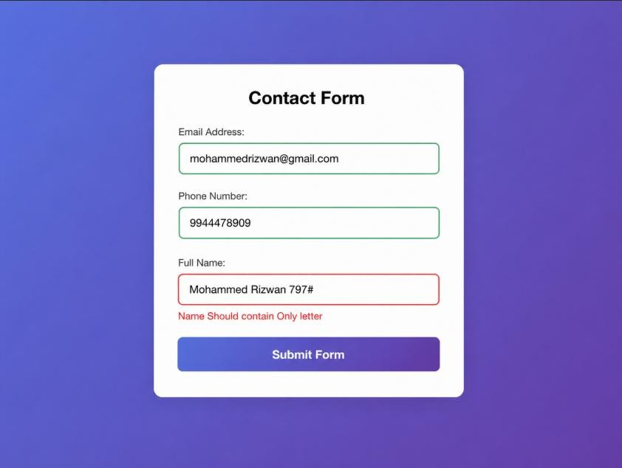

Step 3: Adding JavaScript for Validation Finally, add JavaScript to validate the input fields using Validator.js and display error messages.
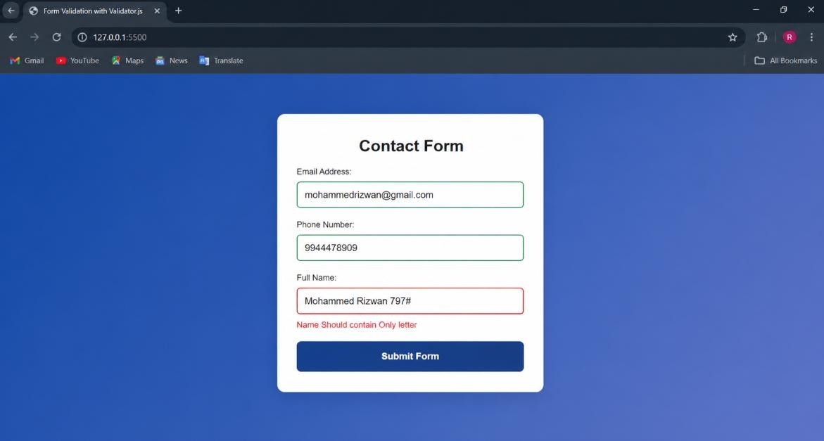
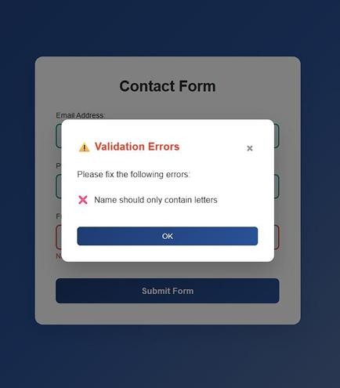

If any input field contains invalid, incomplete, or incorrect data that does not satisfy the required validation conditions, appropriate error messages are automatically generated and clearly displayed in the designated error message area for user guidance.

